
Technical Data Sheet

Product Name：0603 0.45T High Bright White Chip LED
Part Number： GTG1608UWC
Customer：
Customer PN：
Version： A.2
Date： 2013.01.01
Customer Approval

Instituted By： Checked By: Approved By：
SHENZHEN GTLIGHT ELECTRONICS CO., LTD.
TEL： 0755-88999559
FAX： 0755-82555597
Web： http://www.gtgdz.com
1. Features
- Package ( L/W/H ) : 1.6 × 0.8 × 0.45mm
- Color : Ultra Bright Standard White
- Lens: Water Clear Flat Mold
- EIA STD Package
- Meet ROHS, Green Product
- Compatible With SMT Automatic Equipment
- Compatible With Infrared Reflow Solder And Wave Solder Process
2. Package Profile & Soldering PAD Suggested
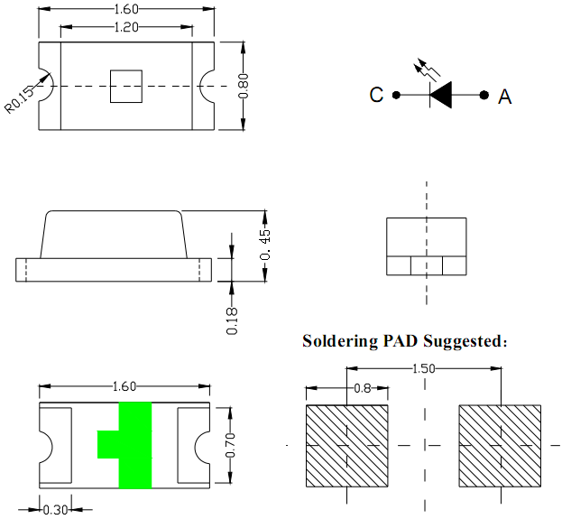

Notes: 1. All dimensions are in millimeters ;
2. Tolerance is ± 0.10 mm unless otherwise noted.
3. Soldering Profile Suggested
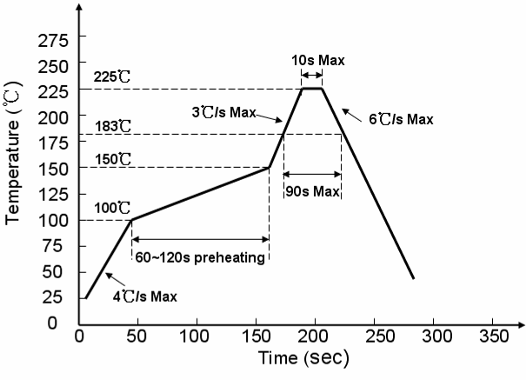
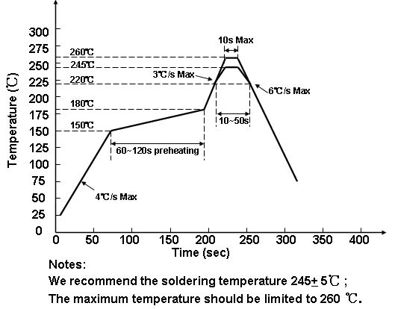
3.1、For Lead Solder

3.2、For Lead Free Solder

4. Absolute Maximum Ratings At Ta=25℃
Parameter | Symbol | Rating | Unit
Power Dissipation | Pd | 90 | mW
Peak Forward Current  (1/10 Duty Cycle, 0.1ms Pulse Width) | IFP | 100 | mA
DC Forward Current | IF | 30 | mA
Reverse Voltage | VR | 5 | V
Operating Temperature Range | Topr | -30°C ~ + 85°C
Storage Temperature Range | Tstg | -40°C ~ + 90°C
Soldering Condition | Tsol | Reflow soldering : 260°C For 5 Seconds  Hand soldering: 300°C For 3 Seconds

5. Electrical Optical Characteristics At Ta=25℃
Parameter | Symbol | Min. | Typ. | Max. | Unit | Test Condition
Luminous Intensity | IV | --- | 350 | --- | mcd | IF = 20mA
Viewing Angle | 2θ1/2 | --- | 120 | --- | deg | IF = 20mA
CIE 1931 Coordinate | X/Y | --- | X:0.29 Y:0.28 | --- |  | IF=20mA
Forward Voltage | VF | 2.8 | --- | 3.4 | V | IF=20mA
Reverse Current | IR | --- | --- | 10 | uA | VR=5V

Notes: 1. Luminous intensity is measured with a light sensor and filter combination that approximates the
CIE eye-response curve.
2. θ1/2 is the off-axis angle at which the luminous intensity is half the axial luminous intensity.
3. The dominant wavelength, λd is derived from the CIE chromaticity diagram and represents the
single wavelength which defines the color of the device.

6. Typical Electrical-Optical Characteristics Curves
7. Label Explanation
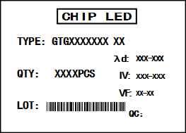
CAT：Luminous Intensity Rank（unit : mcd）
HUE：CIE 1931 Coordinate Rank
REF：Forward Voltage Rank unit : V）

Rank Tolerance:
a. Luminous Intensity: ± 15%
b. HUE: ± 0.01
c. Forward Voltage: ± 0.1V
8.Reel And Tape Dimensions：

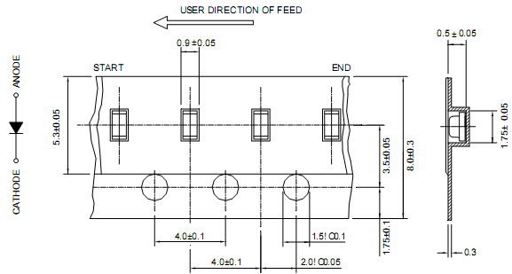
Notes: 1. All dimensions are in millimeters ;
2. Tolerance is ± 0.1 mm unless otherwise noted.
9. Tape Leader & Trailer Dimensions And Reel
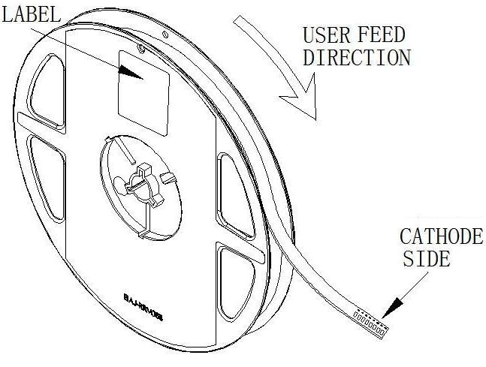
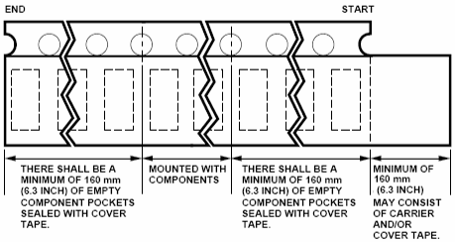

10. Packaging：
Label
Desiccant
Label
10 bags/carton
5 cartons/box

Aluminum moisture-proof bag
Reel
Vacuum

11. Reliability Test
Classification | Test Item | Test Condition | Reference Standard | Reference Standard
Endurance  Test | Operation Life | Ta= Under Room Temperature As Per Data Sheet Maximum Rating | 1000HRS (-24HRS,+72HRS)*@20mA | MIL-STD-750D:1026  MIL-STD-883D:1005  JIS C 7021:B-1
Endurance  Test | High Temperature, High Humidity Storage | IR-Reflow In-Board, 2 Times  Ta= 65±5℃,RH= 90～95% | 240HRS±2HRS | MIL-STD-202F:103B  JIS C 7021:B-11
Endurance  Test | High Temperature  Storage | Ta= 105±5℃ | 1000HRS (-24HRS,+72HRS) | MIL-STD-883D:1008  JIS C 7021:B-10
Endurance  Test | Low Temperature  Storage | Ta= -55±5℃ | 1000HRS (-24HRS,+72H RS) | JIS C 7021:B-12
Environmental  Test | Temperature  Cycling | 105℃ ～ 25℃ ～ -55℃ ～ 25℃  30mins 5mins 30mins 5mins | 10 Cycles | MIL-STD-202F:107D  MIL-STD-750D:1051  MIL-STD-883D:1010  JIS C 7021:A-4
Environmental  Test | Thermal  Shock | IR-Reflow In-Board, 2 Times  85 ± 5℃ ～ -40℃ ± 5℃  10mins 10mins | 10 Cycles | MIL-STD-202F:107D  MIL-STD-750D:1051  MIL-STD-883D:1011
Environmental  Test | Solder  Resistance | T.sol= 260 ± 5℃ | 10 ± 1secs | MIL-STD-202F:210A  MIL-STD-750D:2031  JIS C 7021:A-1
Environmental  Test | IR-Reflow  Normal Process | Ramp-up rate(183℃ to Peak) +3℃/ second max  Temp. maintain at 125(±25)℃ 120 seconds max  Temp. maintain above 183℃ 60-150 seconds  Peak temperature range 235℃+5/-0℃  Time within 5°C of actual Peak Temperature (tp)  10-30 seconds  Ramp-down rate +6℃/second max | -------- | MIL-STD-750D:2031.2  J-STD-020C
Environmental  Test | IR-Reflow  Pb Free Process | Ramp-up rate(217℃ to Peak) +3℃/ second max  Temp. maintain at 175(±25)℃ 180 seconds max  Temp. maintain above 217℃ 60-150 seconds  Peak temperature range 260℃+0/-5℃  Time within 5°C of actual Peak Temperature (tp)  20-40 seconds  Ramp-down rate +6℃/second max | -------- | MIL-STD-750D:2031.2  J-STD-020C
Environmental  Test | Solderability | T.sol= 235 ± 5℃  Immersion rate 25±2.5 mm/sec  Coverage ≧95% of the dipped surface | Immersion time 2±0.5 sec | MIL-STD-202F:208D  MIL-STD-750D:2026  MIL-STD-883D:2003  IEC 68 Part 2-20  JIS C 7021:A-2
12. Cautions
Application
- A LED is a current-operated device. The slight shift of voltage will cause big change of current, which will damage LEDs. Customer should use resistors in series for the Over-Current-Proof.
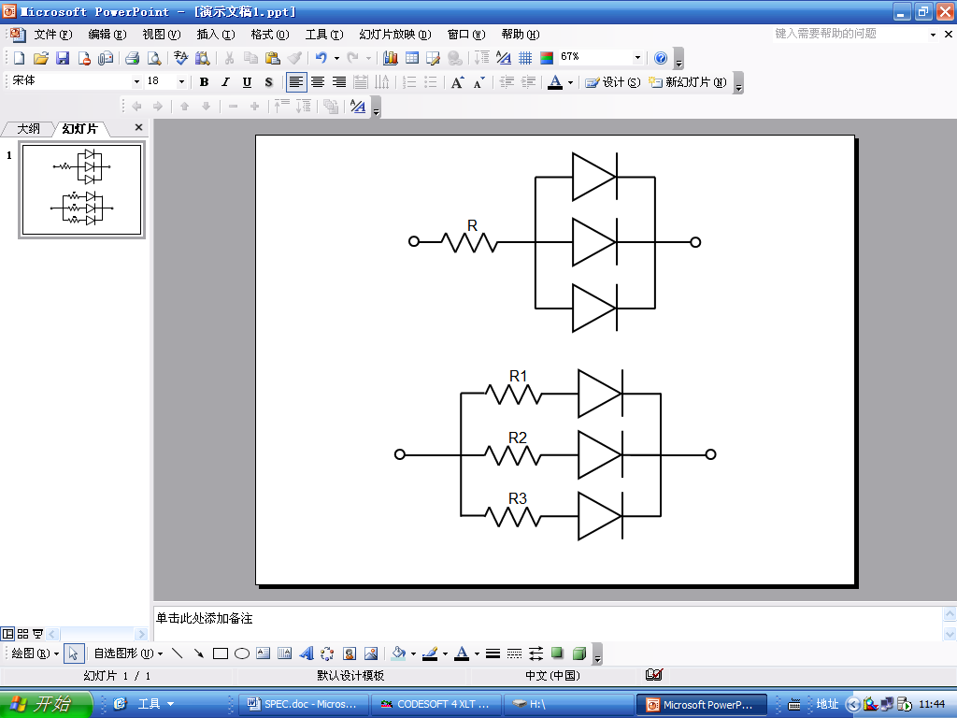
- In order to ensure intensity uniformity on multiple LEDs connected in parallel in an application, it is recommended to use individual resistor separately, as shown in Circuit A below. The brightness of each LED shown in Circuit B might appear difference due to the differences in the I-V characteristics of those LEDs.

Circuit model A Circuit model B

- High temperature may reduce LEDs’ intensity and other performances, so keeping it away from heat source to get good performance is necessary.

Storage
1.Before opening original package, it is recommended to store them in the following environment:
Temperature: 5℃~30℃ Humidity: 85%RH max.
2. After opening original package, the storage ambient for the LEDs should be in 5~30°C temperature and 60% or less relative humidity.
3. In order to avoid moisture absorption, it is recommended that the LEDs that out of the original package should be stored in a sealed container with appropriate desiccant, or in desiccators with nitrogen ambient.
4. The LEDs should be used within 168hrs (7 days) after opening the package. Once been mounted, soldering should be quick.
5. If the moisture absorbent material (silica gel) has faded away or the LEDs stored out of original package for more than 168hrs (7 days), baking treatment should be performed using the conditions: 60℃ at least 24 hours.

ESD (Electrostatic Discharge )-Protection
A LED (especially the Blue、White and Green product) is an ESD sensitive component, and static electricity or power surge will damage the LED. ESD-damaged LEDs will exhibit abnormal characteristics such as high reverse leakage current, low forward voltage, or “no light-up” at low currents, etc.
Some advice as below should be noticed:
1. A conductive wrist strap or anti-electrostatic glove should be worn when handling these LEDs.
2. All devices, equipment, machinery, work tables and storage racks, etc. must be properly grounded.
3. Use anti-static package or boxes to carry and storage LEDs. And ordinary plastic package or boxes is forbidden to use.
4. Use ionizer to neutralize the static charge during handling or operating.
5. All surfaces and objects within 1 ft close to LEDs measure less than 100V.

Cleaning
Use alcohol-based cleaning solvents such as IPA (isopropyl alcohol) to clean LEDs if necessary.

Soldering
- Soldering condition refer to the draft “Soldering Profile Suggested” on page 1.
- Reflow soldering should not be done more than 2 times.
- Manual soldering is only suggested on repair and rework. The maximum soldering temperature should not exceed 300°C within 3 sec. And the maximum capacity of soldering iron is 30W in power.
- During the soldering process, do not touch the lens at high temperature.
- After soldering, any mechanical force on the lens or any excessive vibration shall not be accepted to apply, also the circuit board shall not be bent as well.

Others
- The LEDs described here are intended to be used for ordinary electronic equipment (such as office equipment, communication equipment and household applications).Consult Gtlight’s Sales in advance for the applications in which exceptional reliability is required, particularly when the failure or malfunction of the LEDs may directly jeopardize life or health. (such as in aviation, transportation, traffic control equipment, medical and life support systems and safety devices).
- The light output from the high luminous intensity LEDs may cause injury to human eyes when viewed directly.
3. The appearance and specifications of the product may be modified for improvement without prior notice.

